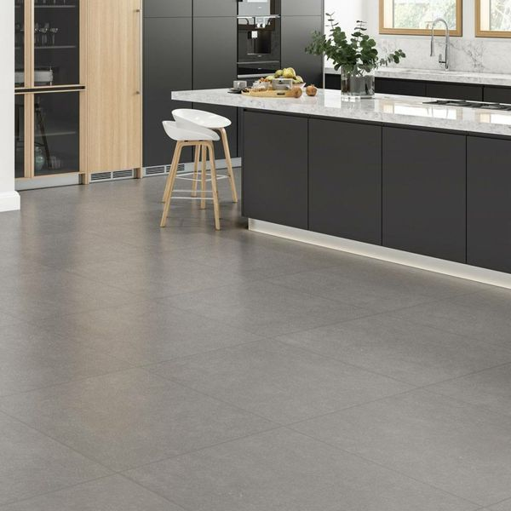**Karlon Ash Grey Tiles:**

## **Product DESCRIPTION**

Karlon Ash Grey Tiles have a beautifully authentic stone effect design with fossil-like detail, inspired by the famous Belgium Bluestone. Suitable for any floor space in the home with its durable matt anti-slip R11 finish, perfect for wet areas and wetrooms.

**What's special about these tiles?**

> Realistic stone effect design  
> Perfect for a calming natural scheme  
> Made from durable porcelain   
> Durable matt anti-slip R11 finish

## **Product Info**

* Product ID: 43784
* Tiles Per SQM: 2.7320538214603
* Sale by: Per SQM
* Size: 605x605x7mm
* Weight: 5.87 KG
* Material Type: Porcelain
* Finish: Matt
* Colour: Grey
* Suitability: Floors
* Grade: 4
* Rectified Edge: No
* Underfloor Heating: Yes
* Anti Slip Grade: R11 / 12 Degrees
* Thickness (mm): 7